 Assignment – 6

**CSE2010 - Advanced C Programming**

**Class Number:** VL2020210504705 **Slot:** L43+L4 **Name :** Prashanth.S **Roll :** 19MID0020

**Question-1**

List out all the standard Library functions: I/O functions, string and character functions, mathematical functions, time, date and localization functions, utility functions, wide-character functions.

**I/O functions**



**String and Character functions**



**Mathematical functions**

**Time and Date functions**

**Localization functions**



**Utility functions**

|  |
| --- |
| **abort - Abnormal termination of a program** |
| **abs - Integer absolute value (magnitude)** |
| **assert - Macro for Debugging Diagnostics** |
| **atexit - Request execution of functions at program exit** |
| **atof - String to double or float** |
| **atoi - String to integer** |
| **bsearch - Binary search** |
| **calloc - Allocate space for arrays** |
| **div - Divide two integers** |
| **ecvtbuf - Double or float to string of digits** |
| **ecvt - Double or float to string of digits (malloc result)** |
| **__env_lock - Lock environment list for getenv and setenv** |
| **gvcvt - Format double or float as string** |
| **exit - End program execution** |
| **getenv - Look up environment variable** |
| **labs - Long integer absolute value (magnitude)** |
| **ldiv - Divide two long integers** |
| **malloc - Allocate memory** |
| **realloc - Reallocate memory** |
| **free - Free previously allocated memory** |
| **mallinfo - Get information about allocated memory** |
| **__malloc_lock - Lock memory pool for malloc and free** |
| **mbstowcs - Minimal multibyte string to wide string converter** |
| **mblen - Minimal multibyte length** |
|  |

**Wide-Character functions**

# **Wide-Character string functions**

# 

# **Wide-Character array function**

# **Conversion functions**

# 

# **Wide-Character I/O functions**

# 

**Question-2**

Write a C program to copy up to n characters from the string pointed to, str1 to str2

**Code**

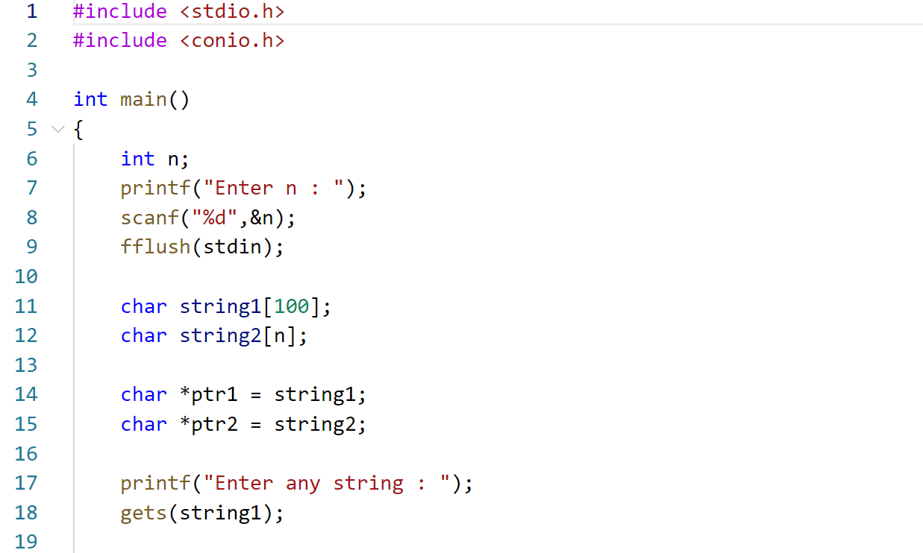  
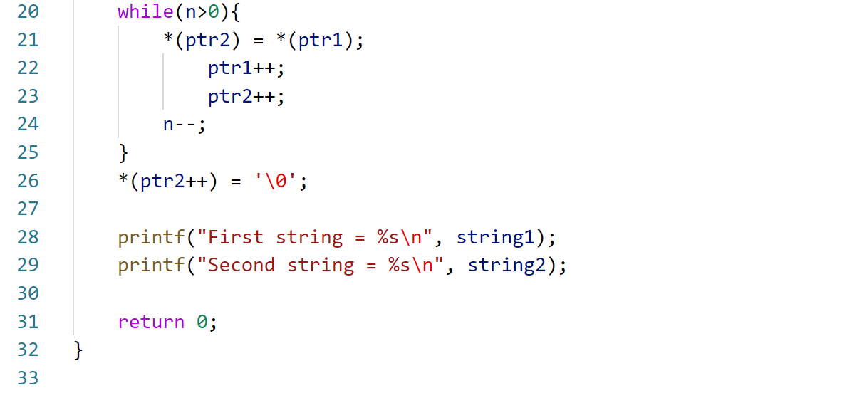

**Output**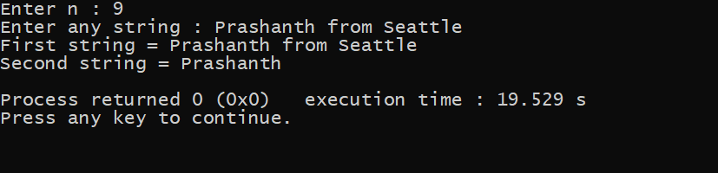

**Question-3**

Write a C program to calculate the length of the initial segment of str1 which consists entirely of characters in str2.

**Code**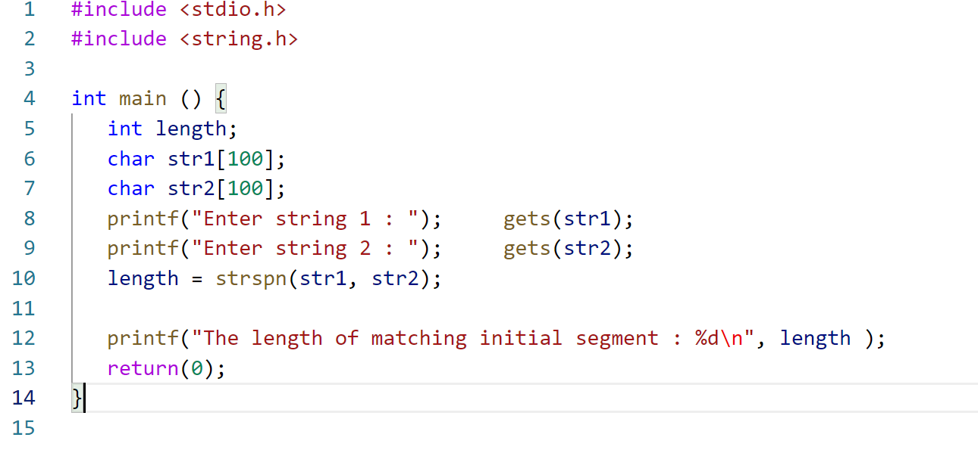

**Output**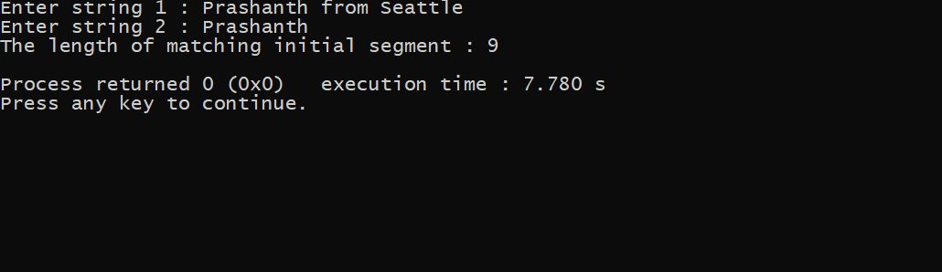

**Question-4**

Write a C program to take a float value and compute the floor for the declared value and rounds to the next value 10.

**Code**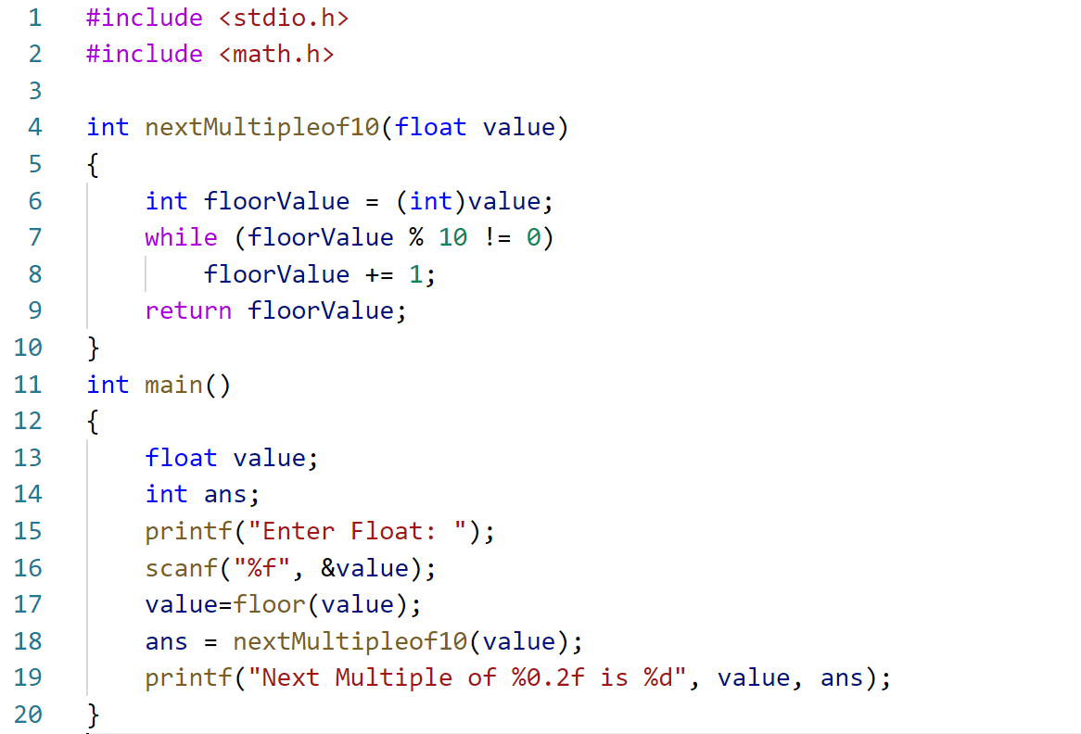

**Output**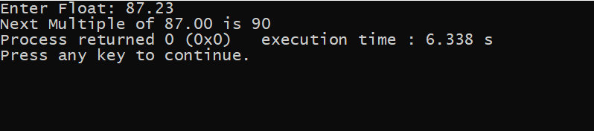

**Question-5**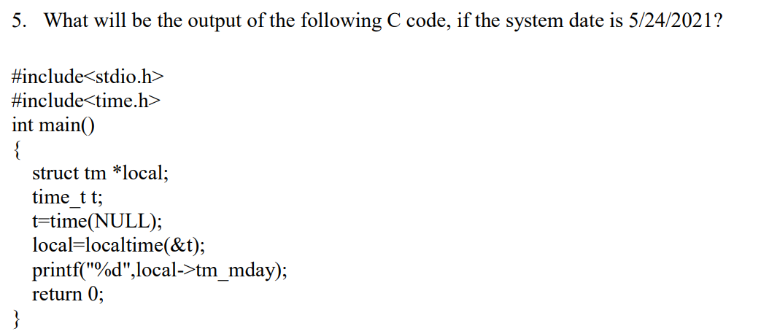

**Code**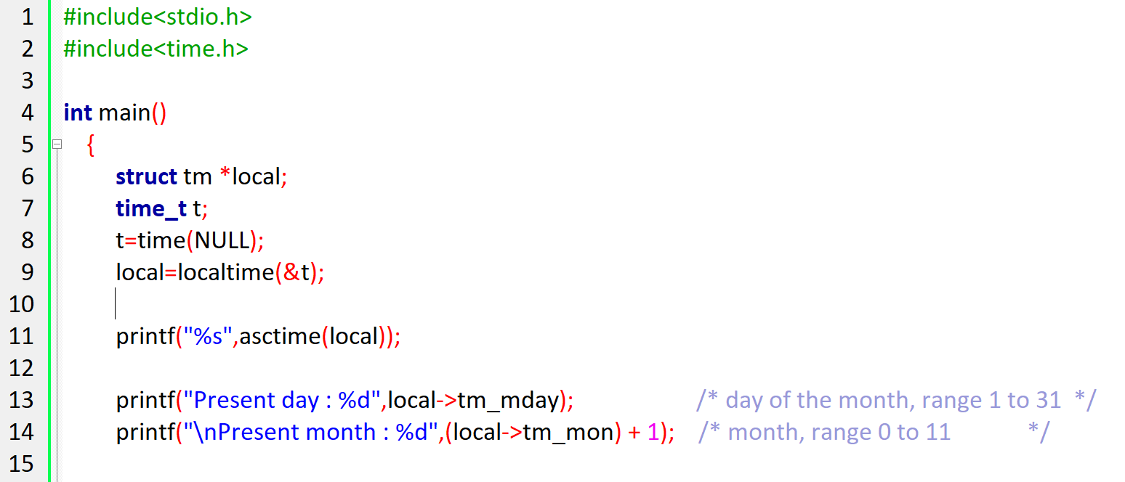

**Output**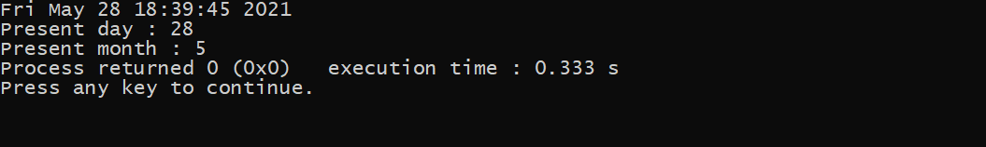

***Answer to the question 🡪 24***

**Question-6**  
Write a C program to take a string input and print the float value of the input.

**Code** 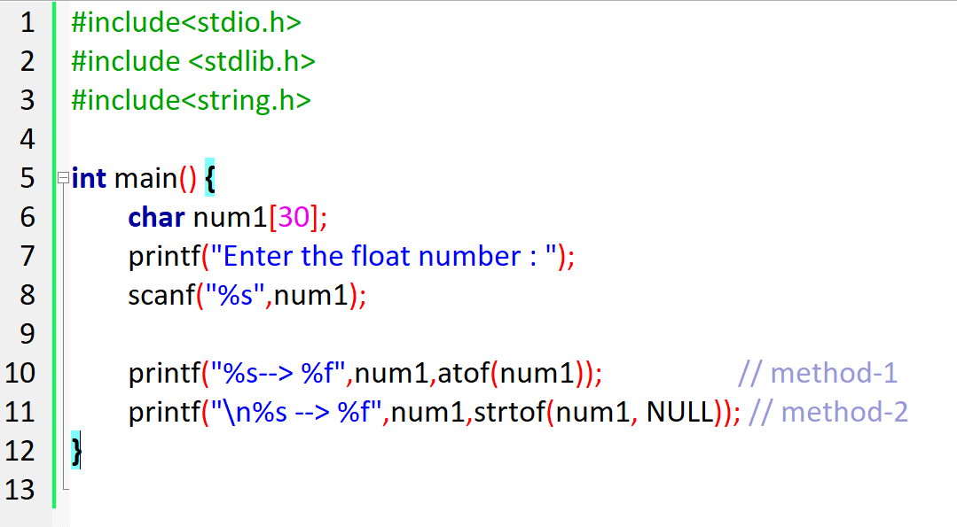

**Output**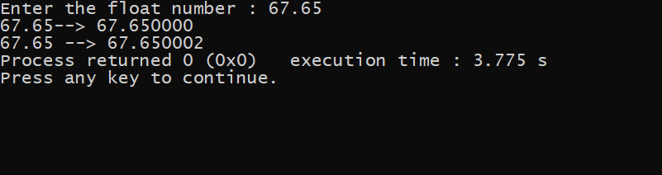

**Question-7**

Write a C program to take a Wide-Character str1 and copy to another string str2 and also print the length of the string.

**Code**

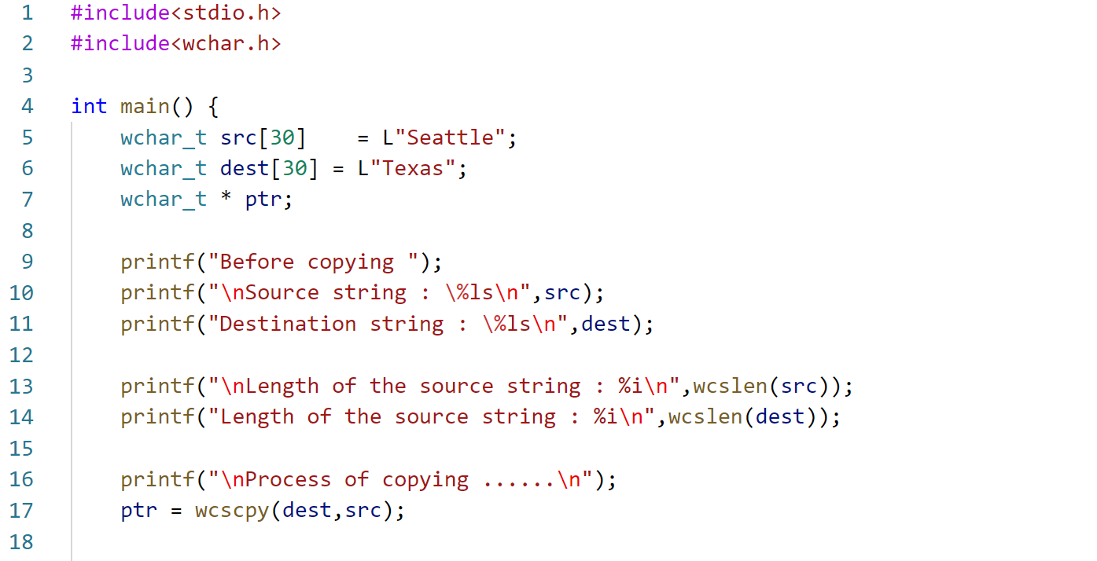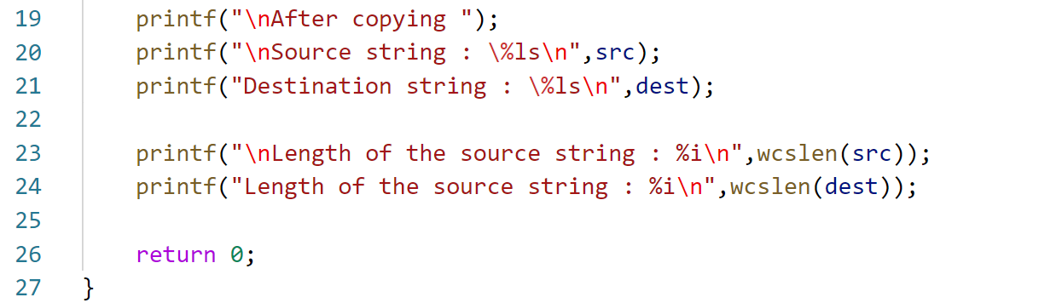

**Output**

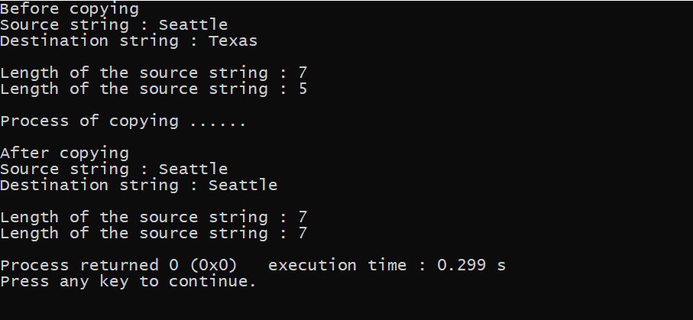

**Question-8**

Write a Unix C program to read the content from a file.

**Code**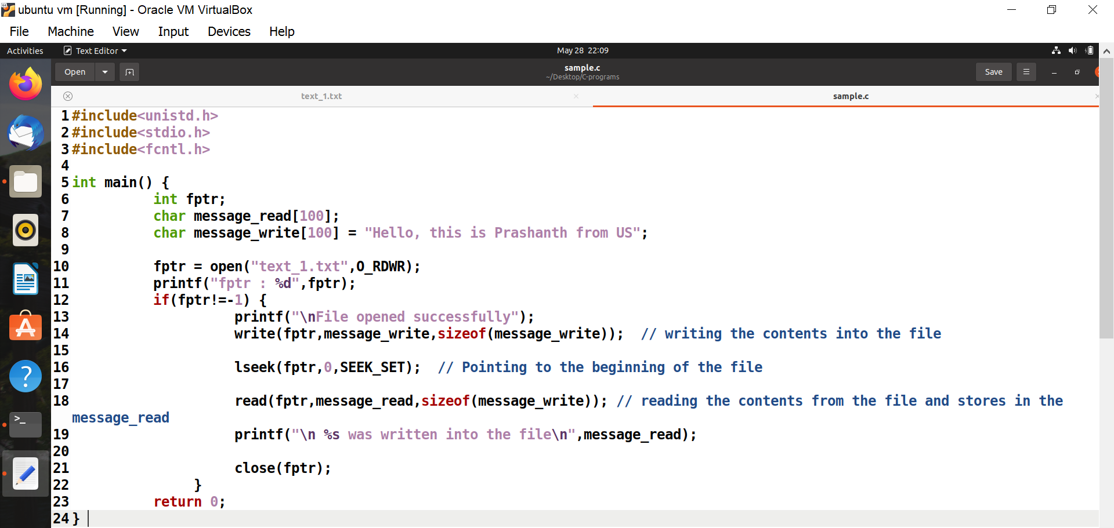

**Output**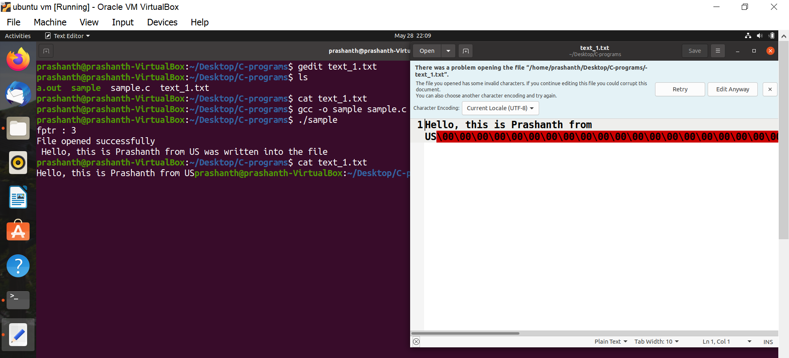

**Source Code**

**Reference**

Question-5

* <https://www.tutorialspoint.com/c_standard_library/c_function_localtime.html>

Question-7

* <https://www.tutorialspoint.com/wide-char-and-library-functions-in-cplusplus>
* <https://www-user.tu-chemnitz.de/~heha/petzold/ch02c.html>
* <https://www.ibm.com/docs/en/i/7.2?topic=functions-wcscpy-copy-wide-character-strings#wcscpy>
* <https://www.ibm.com/docs/en/ssw_ibm_i_72/rtref/wcslen.htm#wcslen>